

Tribhuvan University

Institute of Humanities and Social Science

A PROJECT REPORT

ON

Gym Management System

Submitted to

Department of Computer Application

Swastik College

In partial fulfillment of the requirements for the Bachelors in Computer Application

Submitted By
Aashika Khatiwada (6-2-1131-22-2022)
Safalta Shrestha (6-2-1131-47-2022)

February 2025



Tribhuvan University

Institute of Humanities and Social Science

A PROJECT REPORT

ON

Gym Management System

Submitted to

Department of Computer Application

Swastik College

In partial fulfillment of the requirements for the Bachelors in Computer Application

Submitted By
Aashika Khatiwada (6-2-1131-22-2022)
Safalta Shrestha (6-2-1131-47-2022)
Under the Supervision of
Shristi Khatiwada
February 2025



Tribhuvan University

Institute of Humanities and Social Science

Swastik College

Supervisor’s Recommendation

I hereby recommend that this project prepared under my supervision by AASHIKA KHATIWADA and SAFALTA SHRESTHA entitled “Gym Management System” in partial fulfillment of the requirements for the degree of Bachelor of Computer Application is recommended for the final evaluation.

..............................
SUPERVISOR
Shristi Khatiwada
Swastik College
Chardobato, Bhaktapur



Tribhuvan University

Institute of Humanities and Social Science

Swastik College

LETTER OF APPROVAL

This is to certify that this project prepared by AASHIKA KHATIWADA and SAFALTA SHRESTHA entitled “Gym Management System” in partial fulfillment of the requirements for the degree of Bachelor of Computer Application has been evaluated. In our opinion it is satisfactory in the scope and quality as a project for the required degree.

........................................  Shristi Khatiwada  Lecturer  Swastik College, Chardobato, Bhaktapur | ............................................  Shristi Khatiwada  Coordinator  Swastik College, Chardobato, Bhaktapur
..............................................  Internal Examiner | ................................................  External Examiner

ABSTRACT

This gym management system aims to elevate the fitness experience for both gym members and administrators. Shapeshifter Fitness and Gym is designed to provide a complete fitness experience with online and offline workout plans, personal trainers, and memberships tailored to individual goals. Our gym features the best equipment, along with classes in Zumba, cardio, boxing, and weightlifting to suit a variety of fitness interests. Users can also rent or purchase gym equipment and buy proteins and other diet products directly from us. This approach ensures members have the flexibility and resources they need to pursue fitness both at the gym and at home.
Built using HTML, CSS, JavaScript, SQL and PHP, the system ensures database management and efficient server-side operations. It facilitates CRUD operations for managing user data, schedules and progress tracking. The project aims to streamline gym administration, boost user engagement, and support future enhancements, making it a comprehensive tool for modern gym management.

Keywords: Gym Management System, Fitness experience, Process tracking, CRUD operations, Database management, HTML, CSS, JavaScript, SQL, PHP

ACKNOWLEDGEMENT

We are obliged to a number of people who helped us to organize this project and thankful for their kind opinions, suggestions, and appropriate guidelines. We have received endless support and guidance in finalizing our project so we would like to take this opportunity to thank them all.
First and foremost, we would like to express our special thanks of gratitude to our supervisor Mrs Shristi Khatiwada, who gave us the honor to do this wonderful project on the topic (Gym Management System HTML, CSS, JavaScript, PHP), which has helped us a lot in sharpening our knowledge. WE are also thankful for her continuous feedback and encouragement throughout the project. Without her grace, this project could not have become accomplished. Moreover. We came to know many new things while doing the project so, deeply thankful to her.
Secondly, we are overwhelmed with all the support and guidance that we got from our friends. They have assisted us from time to time in making this project satisfactorily complete by giving innovative ideas. So, we would like to thank them for helping us in making the project wonderful and unique.
At last but not least, we are thankful to all who have been always encouraging and helping us to cope with the challenges that we faced during the completion of the project.

With Regards;
Aashika Khatiwada
Safalta Shrestha

List of Abbreviations

CASE tools – Computer Aided Software Engineering tools
CSS – Cascading Style Sheet
DFD – Data Flow Diagram
ER – Entity Relationship
HTML – Hypertext Markup Language
JS – JavaScript
PHP – PHP Hypertext Preprocessor
SQL – Structured Query Language

Table of Content

Supervisor’s Recommendation I
LETTER OF APPROVAL II
ABSTRACT III
ACKNOWLEDGEMENT IV
List of Abbreviations V
Table of Contents VI
List of Figures VIII
List of Tables IX
Chapter 1: Introduction 1
1.1 Introduction 1
1.2 Problem Statement 2
1.3 Objectives 2
1.4 Scope and Limitation 2
1.4.1 Scope 2
1.4.2 Limitations 2
1.5 Report Organization 3
Chapter 2: Background Study and Literature Review 4
2.1 Background Study 4
2.2 Literature Review 4
Chapter 3: System Analysis and Design 6
3.1 System Analysis 6
3.1.1 Requirement Analysis 6
3.1.2 Feasibility Analysis 8
3.1.3 Data Modeling (ER-Diagram) 10
3.1.4 Process Modeling(DFD) 11
3.2 System Design 12
3.2.1 Architectural Design 12
3.2.2 Database Schema Design 13
3.2.3 Interface Design (Interface Structure Diagrams) 13
Chapter 4: Implementation and Testing 16
4.1 Implementation 16
4.1.1 Tools Used (CASE Tools, Programming Language, Database Platforms) 16
4.1.2 Implementation Details of Modules (Description of procedures/functions) 17
4.2 Testing 19
Chapter 5: Conclusion and Future Recommendations 21
5.1 Lesson Learnt/Outcome 21
5.2 Conclusion 22
5.3 Future Recommendation 22
References 23

List of Figures

Figure 3-1: Use Case Diagram..........................................................................................7
Figure 3-2: Gantt Chart.....................................................................................................9
Figure 3-3: E-R Diagram.................................................................................................10
Figure 3-4: 0 level DFD...................................................................................................11
Figure 3-5: 1 level DFD...................................................................................................11
Figure 3-6: Architectural Design.....................................................................................12
Figure 3-7: Database Schema..........................................................................................13
Figure 3-8: Home Page....................................................................................................13
Figure 3-9: Login Form....................................................................................................14
Figure 3-10: Registration Form........................................................................................14
Figure 3-11a: Dashboard (Overview)...............................................................................14
Figure 3-11b: Dashboard (Membership, Workouts, Equipment) ....................................15
Figure 3-11c: Dashboard (Make Payment, Profile) .........................................................15

List of Tables

4.2.2 Test Cases for User Registration in the HTML Form..............................................19
4.2.2 Test Cases for User Login in the HTML Form........................................................20

Chapter 1: Introduction

Introduction
A gym management system is a software that simplifies the daily operations of a gym, fitness center or health club by managing memberships, scheduling, payments and staff tasks in centralized platform. These systems have become increasingly popular nowadays and widely used today for enhanced operational efficiency, streamlined billing and payment processing, inventory and equipment maintenance and also for marketing and member outreach.
A gym is a facility equipped with various types of exercise and fitness equipment where people go to engage in physical activities, improve their fitness levels and maintain a healthy lifestyle. Gym typically offer a range of exercise options such as weightlifting, cardiovascular workouts, group classes like yoga, spinning and sometimes specialized training programs. Gym management system acts as a digital backbone that optimizes these services and enhance the member experience. So, it requires that the gym management system should be very convenient and provides us a range of tools and features that streamline gym operations and support business growth.
Gym management system stands out by offering both online and offline options, making it easy for people with different schedules to stay active. It offers diverse services like personal training, dance, Zumba, cardio and boxing. By providing equipment rentals and diet products, it becomes a convenient one-stop shop. With a distinctive name like “Shape-Shifter Fitness and Gym”, its stands out and reflects a strong commitment to integrity.

Problem Statement
Gyms relying on manual processes face challenges like inaccurate membership tracking, which impacts attendance, renewals, and revenue. Equipment management becomes inefficient, leading to higher maintenance costs and member dissatisfaction. Manual payment processing is error-prone and time-consuming, creating bottlenecks during peak hours. Additionally, storing sensitive data manually increases security risks and compliance concerns.
The implementation of gym management system offering several advantages including both online and offline options, diverse services like personal training, dance, Zumba, cardio and boxing, also providing equipment rentals and diet products.

Objectives
The main objective of the system is to develop an online-based web application for gym management system using HTML, CSS, JavaScript, SQL and PHP.

Scope and Limitation

1.4.1 Scope
A gym management system offers comprehensive features like membership management to track member details, registrations, renewals, and personal information seamlessly. It enables members to rent or purchase training equipment and buy diet products conveniently, making the gym a one-stop solution for fitness needs. Additionally, it includes a BMI calculation feature to recommend personalized workouts based on individual health metrics, enhancing the overall fitness journey.

1.4.2 Limitations
- Since the system is online web-based application, so poor internet connectivity can make it challenging for gym members.
- Members might be concerned about their personal information.
- Technical errors or system downtime could interrupt gym operations, affecting check-ins and overall member experience.

Report Organization
- he first part of the report contains the summarized introduction of the whole report. It
- includes the overview, scope and limitation, problem statement and objectives of this
- project.
- The second chapter includes background study i.e. description of fundamental theories,
- general concepts and terminology related to the project. It also includes the literature review
- i.e. review of the similar projects, research and theories done by other researchers.
- The third chapter includes the system analysis and design phase in which the report
- of functional and non-functional requirements of the project is stated using use case and
- system diagrams. It also includes the feasibility study about the system which explains
- whether the system development process is affordable and within the knowledge range of
- the developers. It shows the technical, operational and economic feasibility of the project
- development phase. The explanation of the designing of the system is also done in this
- chapter. It includes data modeling and process modeling which is explained by using ER
- diagram and Data Flow Diagram. The architectural design, database design and the user
- interface design is also listed in this chapter.
- The fourth chapter includes the implementation and testing phase of the proposed system.
- In the implementation phase, the tools like CASE tools, programming languages and
- database platforms are implemented.
- The fifth chapter includes conclusion and future recommendation. This contains the
- final paragraphs of the report and in this phase the overall outcome and the developer s‟
- point of view is written. The lesson that I learned through all the phases can also be included
- in this phase
The first part of the report contains the summarized introduction of the whole report. It includes the overview, scope and limitation, problem statement and objectives of this project.
The second chapter includes background study i.e. description of fundamental theories, general concepts and terminology related to the project. It also includes the literature review i.e. review of the similar projects, research and theories done by other researchers.
The third chapter includes the system analysis and design phase in which the report of functional and non-functional requirements of the project is stated using use case and system diagrams. It also includes the feasibility study about the system which explains whether the system development process is affordable and within the knowledge range of the developers. It shows the technical, operational and economic feasibility of the project development phase. The explanation of the designing of the system is also done in this chapter. It includes data modeling and process modeling which is explained by using ER diagram and Data Flow Diagram. The architectural design, database design and the user interface design is also listed in this chapter.
The fourth chapter includes the implementation and testing phase of the proposed system. In the implementation phase, the tools like CASE tools, programming languages and database platforms are implemented.
The fifth chapter includes conclusion and future recommendation. This contains the final paragraphs of the report and in this phase the overall outcome and the developer’s point of view is written. The lesson that I learned through all the phases can also be included in this phase.

Chapter 2: Background Study and Literature Review

2.1 Background Study
A gym management system is an integrated software solution designed to streamline and automate various aspects of gym operations, including membership management, payment processing, many more. As the fitness industry has expanded significantly in recent years, demand for efficient management systems has grown, allowing gyms to focus more on providing quality services and less on administrative tasks.
Traditionally, gyms relied on manual processes for member registration, subscription tracking, and check-ins, which often led to inefficiencies and human errors. Modern gym management systems address these issues by centralizing data, allowing for real-time updates, and automating workflows.
The rise of digital tools in the fitness industry reflects broader trends in customer preferences for digital self-service and personalized experiences. As a result, implementing a robust gym management system is not only essential for operational efficiency but also for improving member engagement and satisfaction. This study explores the functionalities, benefits, and potential challenges of gym management systems, aiming to provide insights into their impact on the fitness industry.

2.2 Literature Review
A thorough investigation of existing systems will provide valuable benchmarks and help us identify unique features that can differentiate our project. A gym management system is really important for keeping everything organized and making sure members have a great experience.
Mindbodyonline.com is a platform where users can easily search for fitness classes by type, location and timing. Both of these systems use the information from users to make their experience better and help them stay on track with their fitness goals. [1]
The business of personal training focused on personal training and fitness administrators. It discusses the importance of management systems in running a fitness business effectively. [2]
Two-Brain Business: Grow Your Gym provides insights into building and scaling a successful gym business, focusing on financial management, client retention and sustainable growth strategies. [3]
A complete guide to gym management offers insights into managing a fitness business, highlights the key features gym owners should look for in gym management systems with a focus on increasing operational efficiency and member engagement. [4]
Fitness Management: A Comprehensive Approach focuses on all aspects of managing a fitness center, including managing members, finances and technology. It includes practical examples and case studies that explore the benefits of integrating gym management systems into daily operations. [5]
International Journal of Sports Science and Fitness highlights features like progress tracking, class booking and member communication as key factors for enhancing user experience. [6]
International Fitness Association Report traces the history of gym management software from its early days to the current stage where integrated systems provide a complete business solution. It discusses the integration of features like mobile apps and cloud storage. [7]
Fitness Industry Quarterly looks at the barriers and benefits for smaller gym adopting management software. It examines challenges like cost, training and resistance to change. [8]
Fitness Business Podcast explores the latest trends in gym management software. It provides insights into upcoming software developments and includes interviews with fitness business owners who share their experiences using management systems. [9]
For instance, websites like gymcatch.com let users sign up, book classes and keep track of their own accounts to manage their memberships and even get personalized workout suggestions based on what they want to achieve. [10]

Chapter 3: System Analysis and Design

3.1 System Analysis
System analysis aims to evaluate the feasibility of the system concept, allocate functions to hardware, software, personnel and database, and establish cost and schedule constraints to ensure the system is practical, efficient and achievable within defined limits.
System Analysis refers into the process of examining a system with the intent of improving it
through better procedures and methods. It is the process of planning a new system to either
replace or complement an existing system. It is therefore, the process of gathering and
interpreting facts, diagnosing problems and using the information to re- comment
improvements in the system. System analysis is conducted with the following objectives in
mind:
•Evaluate the system concept for feasibility.
•Perform economic and technical analysis.
•Allocate functions to hardware, software people, database and other system elements.
•Establish cost and schedule constraints.

3.1.1 Requirement Analysis
3.1.1.1 Functional Requirements
Functional requirements detail the operations and functions that the system must perform. They describe how users interact and complete actions within the system. Such as:
- Users should able to calculate their BMI by entering their weight, with the system returning the BMI value. Also recommended workout based on their BMI value.
- Users should be able to register and log in
- Users should allow to log workouts, track progress and receive personalized workout recommendations based on BMI, fitness level or goal.
- Users should allow to manage their gym memberships, renew or update them.
- Users should allow to track/search equipment details, purchase and rent fitness equipment.
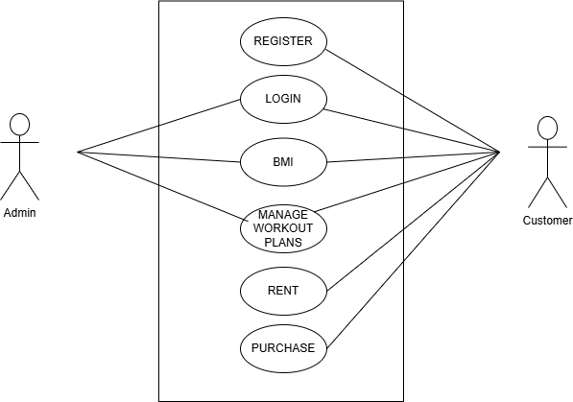
3.1.1.2 Non Functional Requirements
Figure 3-1 Use Case Diagram
Performance:
- The system should respond to user actions such as updating membership details within a few seconds to ensure a smooth experience for users.
- The system should be efficiently managing user load, with the capacity to support 300 concurrent users.
- The system should be efficiently handle a high volume of transactions including membership, class scheduling, workouts to meet user demand without delays.
Security:
- To protect user privacy all sensitive data including payment details should be encrypted during both transmission and storage.
Usability:
- The system should provide a simple, easy-to-navigate interface for all users, ensuring tasks like workout tracking to accessible on any devices.

3.1.2 Feasibility Analysis
3.1.2.1 Technical Feasibility
Technical feasibility for a gym management system looks at whether the right technology, data and skills are available to create and maintain key features. It is important to have access to data about gym services and user preferences for personalized recommendations and the system should work well with existing tools. Vs code, HTML, CSS, JavaScript, PHP, MySQL, Xampp are used to develop the proposed system.
3.1.2.2 Operational Feasibility
Operational feasibility for a gym management system evaluates whether the system can be smoothly integrated into daily operations and effectively used by staff and clients. It looks at whether the system matches the gym’s workflows for tasks like scheduling classes, managing membership and processing payments. The system should make things easier, reduce manual work and adapt to the gym’s specific needs. Additionally, it considers the training staff will need and the support available for ongoing maintenance to keep everything running smoothly.
3.1.2.3 Economic Feasibility
This project is economically feasible as all required tools and resources are either open source or free. By leveraging cost-effective technologies, we keep development within budget while ensuring high quality and reliability. The development process for this web application is scheduled over a three-month period with specific stages for planning, development, testing and deployment.
iv) Schedule Feasibility
This includes the project schedule and all time allocated for their completion. The Gantt chart is as follow:
Figure 3-2 Gantt Chart

3.1.3 Data Modeling (ER-Diagram)
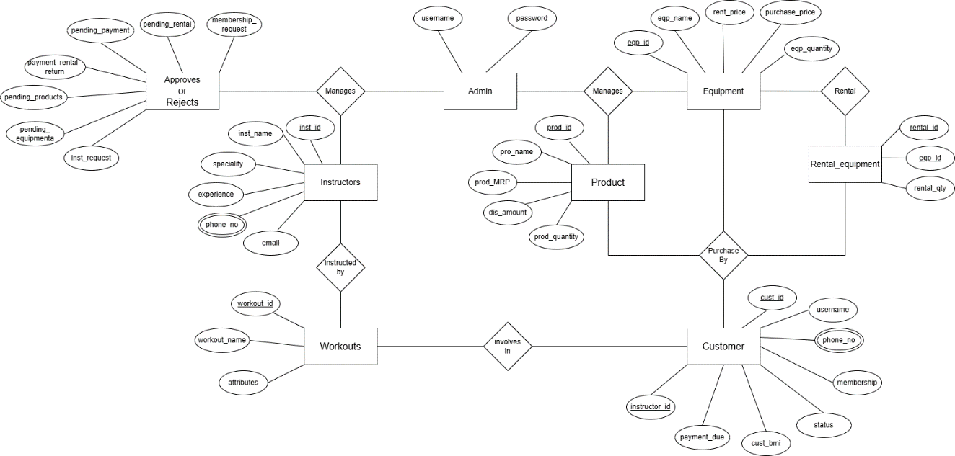
Figure 3-3 ER-Diagram

3.1.4 Process Modeling(DFD)
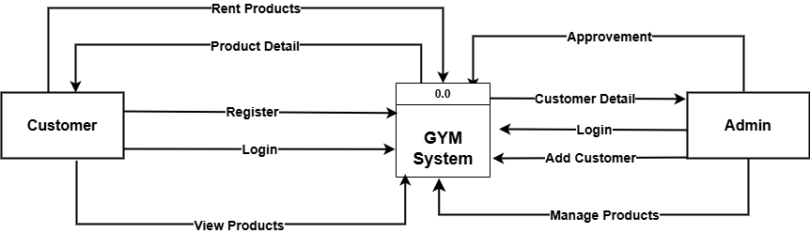
Figure 3-4 0 level DFD

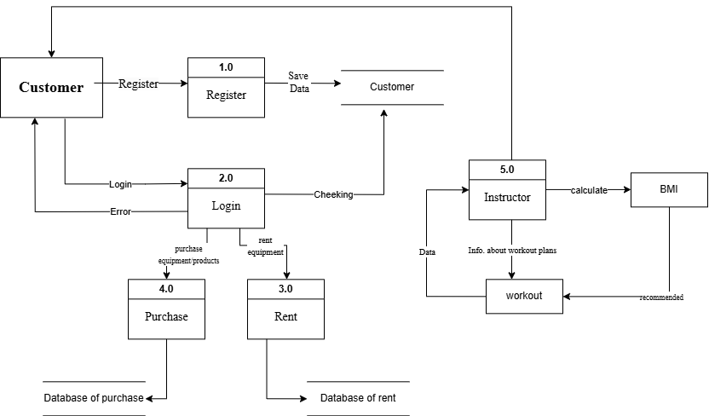
Figure 3-5 1 level DFD

3.2 System Design

3.2.1 Architectural Design
Architectural design is a process for identifying the sub-systems making up a system and the framework for sub-system control and communication.

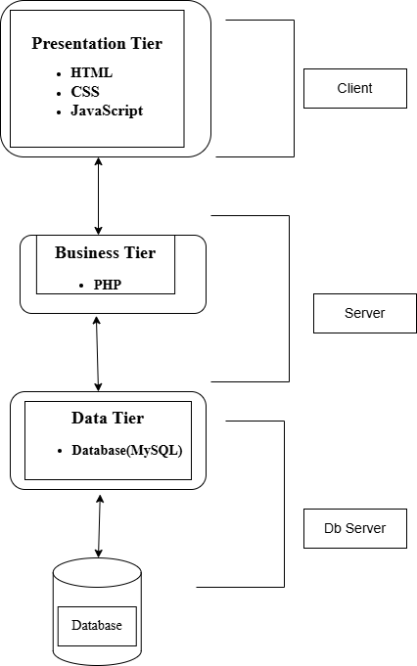
Figure 3-6 Architectural Design

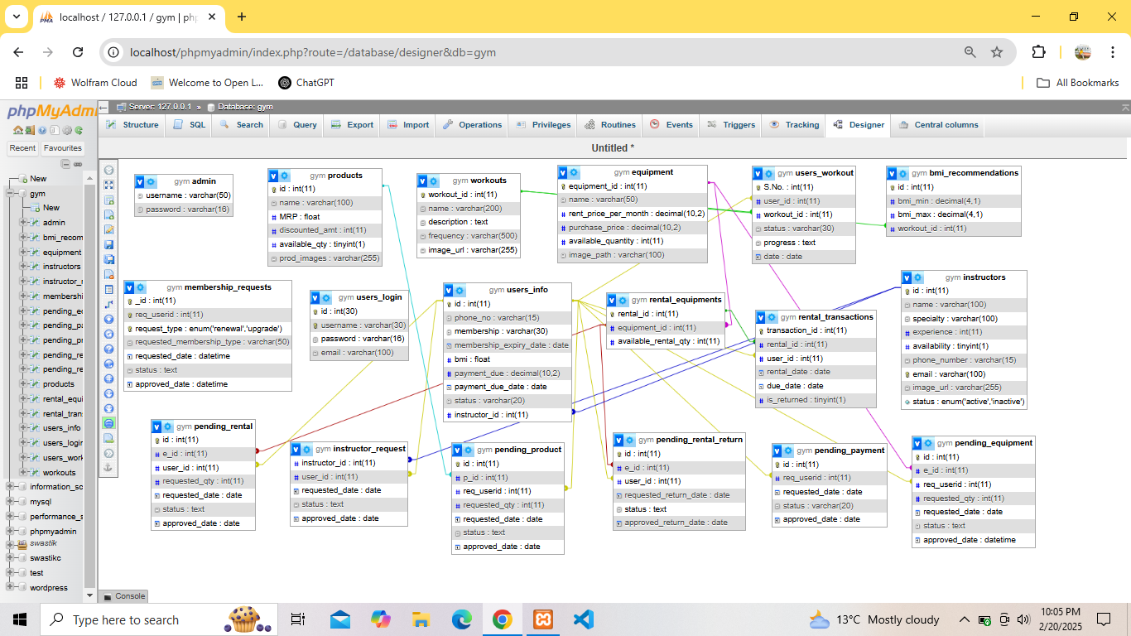
3.2.2 Database Schema Design
Figure 3-7 Database Schema

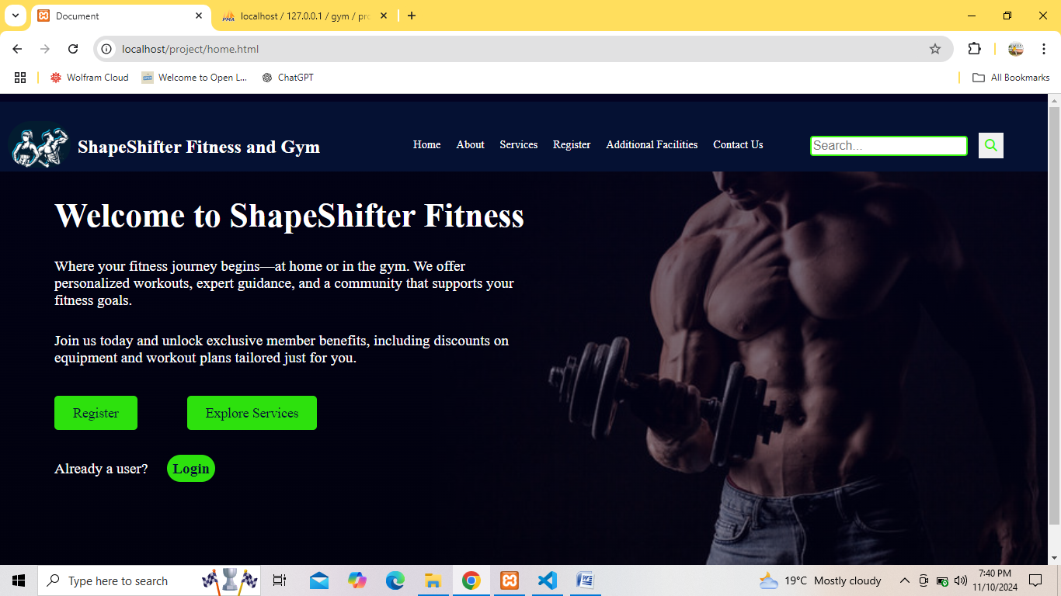
3.2.3 Interface Design (Interface Structure Diagrams)
Figure 3-8 Home Page
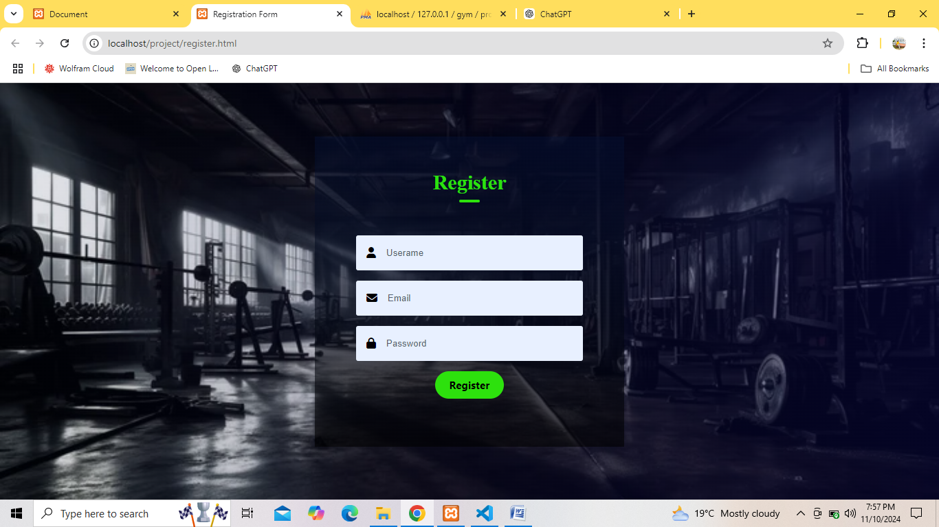
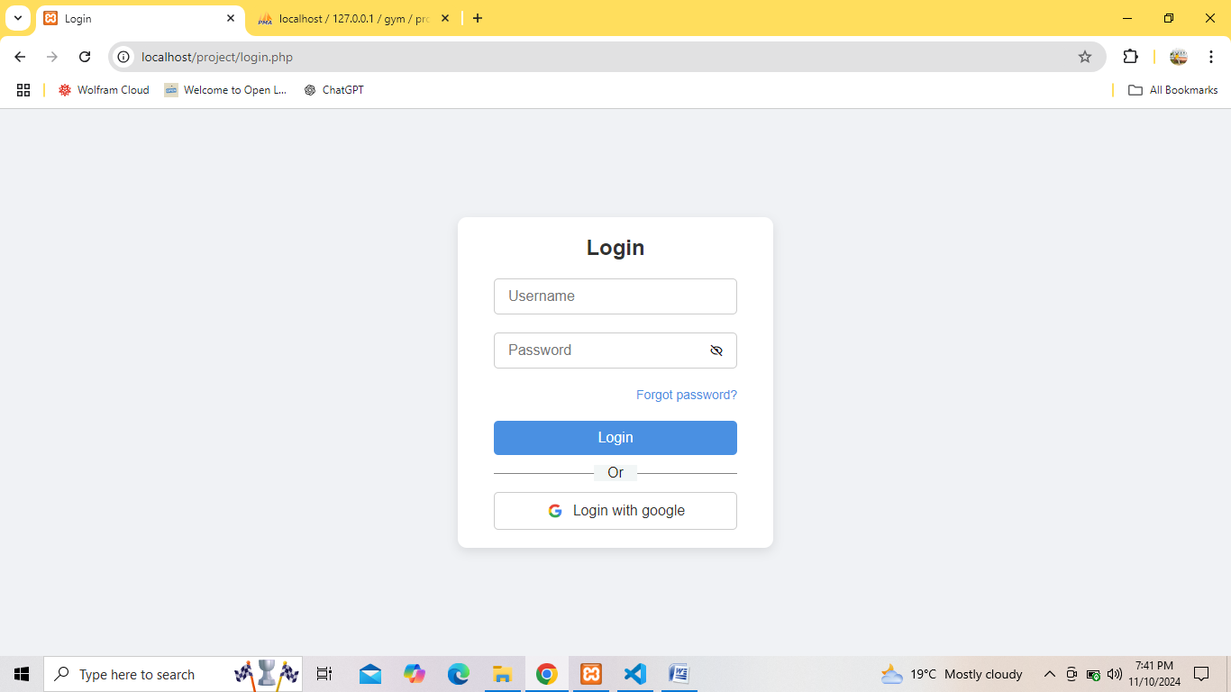
Figure 3-10 Registration Form
Figure 3-9 Login Form

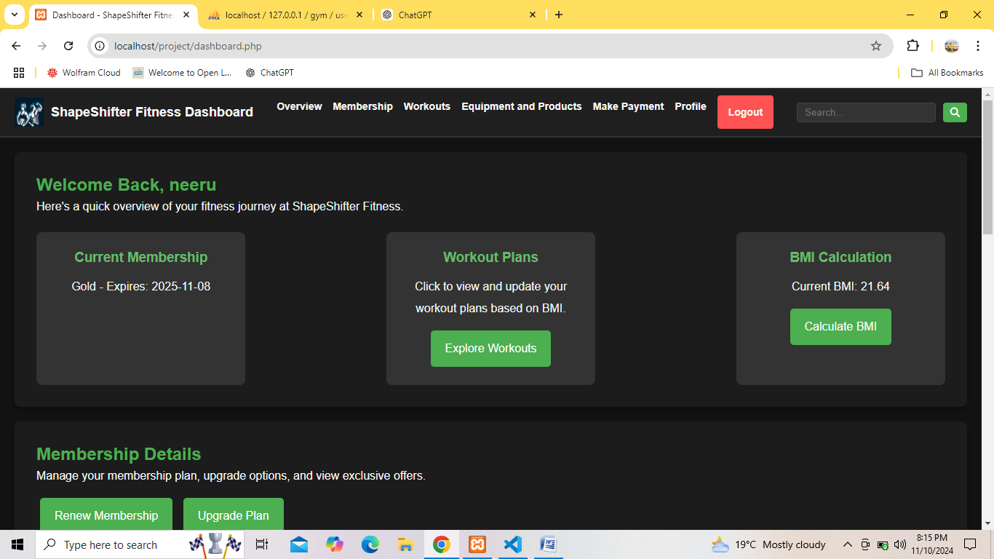
Figure 3-11a Dashboard (Overview)
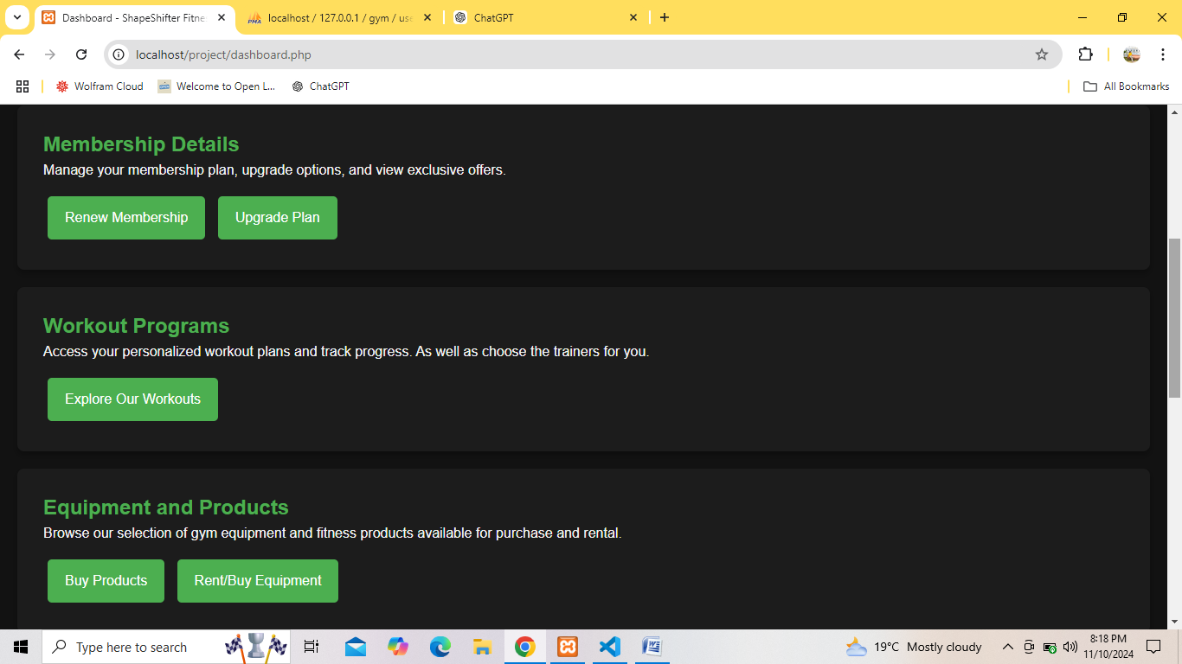
Figure 3-11b Dashboard (Membership, Workouts, Equipment)
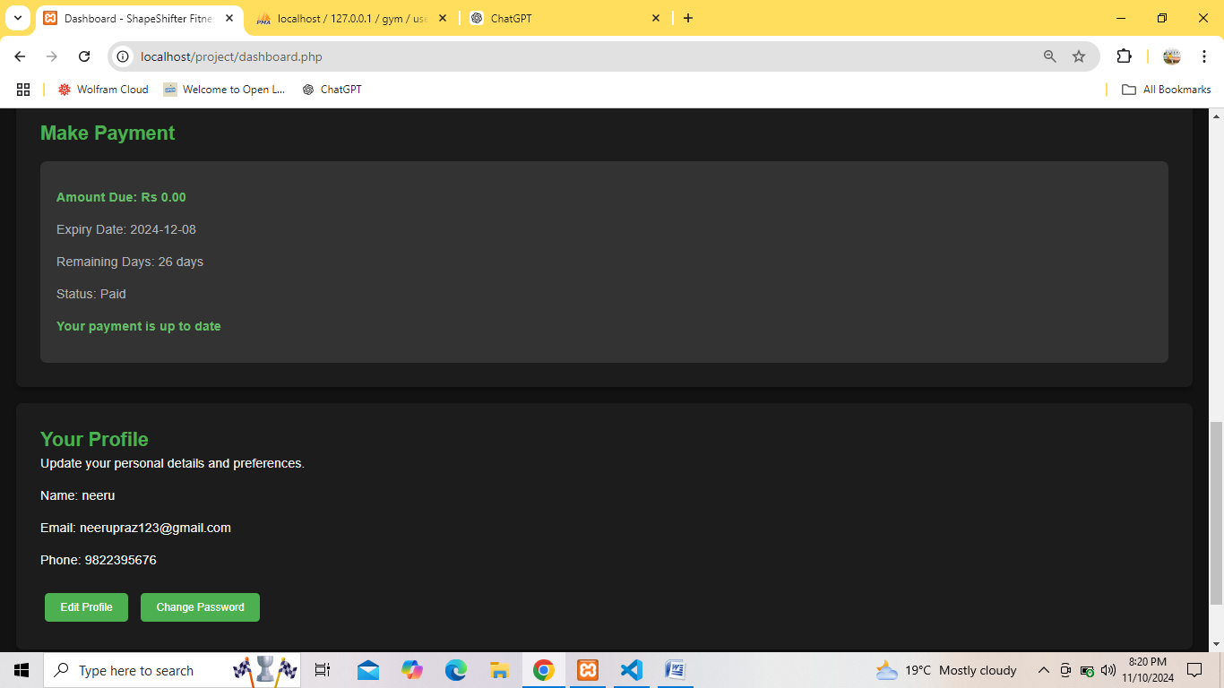
Figure 3-11c Dashboard (Make Payment, Profile)

Chapter 4: Implementation and Testing

4.1 Implementation

4.1.1 Tools Used (CASE Tools, Programming Language, Database Platforms)
4.1.1.1 Frontend Tools
- HTML
HTML stands for Hypertext Markup Language is a foundational language used in web development for creating web pages and websites. In our project, we used html to create and structure sections, heading, links, paragraphs using various tags and elements. HTML ensures structured content, compatibility, accessibility, search engine optimization, integration, scalability and community support in web development. As, HTML is fast, easy and gives good see interface, we choose it as frontend tool.
- CSS
CSS stands for Cascading Style Sheet is a stylesheet language used to control the presentation of HTML elements on a webpage. In our project, we used CSS to apply styles such as colors, size, fonts, layouts, spacing and animations to create visually appealing and responsive designs. As, CSS is an essential tool for building modern, dynamic and user-friendly web interfaces, we choose it as frontend tool.
- JavaScript
JavaScript is a programming language used in web development to make the website responsive and interactive by adding different functionalities of it. Mainly, JavaScript was used for client-side validation, animations and to add the dynamic behavior to the web page. As, JavaScript simplifies the development of complex, responsive and modern user interfaces, we choose it as frontend tool.
4.1.1.2 Backend Tools
i. PHP
PHP is used in web development to create dynamic we page and to add connectivity to database. It is also used for server-side validation. In this project, PHP as backend language to connect to database and to help in performing the CRUD operations.

4.1.1.3 Database Tools
i. MySQL
We used MySQL for storing all the information about the gym management system. XAMPP, a software distribution which provides the Apache web server, MySQL and database all in one package was used. XAMPP was used to develop a local server for data storage and providing base for database.
4.1.1.4 Design Tools
i. Draw.io
This tool was used to create diagrams like DFD, ER diagram, Use Case Diagram, Architectural Design for system analysis and design.
- Excel
This tool was used to create diagram like Gantt Chart for allocating time period for the completion of the project.

4.1.2 Implementation Details of Modules (Description of procedures/functions)
4.1.2.1 Registration Module
The Registration Module provides a facility where users can register by filling in the Signup form with fields like username, email, and password. It then applies validation rules to ensure the user input is correct, and only when all fields meet the required criteria does the registration process get completed. This will serve as the entry point for different users to access the gym management system.
4.1.2.2 Login Module
The Login Module is responsible for user authentication. The user is supposed to log in with a registered username and password to access the system. If the username and password match those on record, they are navigated to the dashboard; otherwise, access is denied. This module ensures that only authorized users can log in, thus maintaining the security of the system.

4.1.2.3 Membership Module
The Membership Module allows users to view details of their current membership, including its type. From the dashboard, members may renew or upgrade their memberships. Administrators can approve new applications and monitor expiration dates, ensuring that all users within the system run seamlessly.
4.1.2.4 Workout Module
The Workout Module allows users to get workout plans based on their BMI and goals. Users can browse different programs of workouts, choose workouts based on their interest, and even select personal trainers who will coach them. Admins approve the trainers for quality and relevance to users.
4.1.2.5 BMI Module
The BMI Module calculates and displays users' BMI, thereby letting them understand their fitness levels. It, then, gives them recommended workout and diet plans, based on their BMI calculations. This module will help the user monitor their health and make necessary changes to the routines.
4.1.2.6 Equipment and Product Management Module
The Equipment and Product Management Module enables users to browse, rent, or purchase gym equipment and fitness products. All listings are verified and approved by admins before they go live for users. This module ensures that only quality and verified products are available, increasing user trust and satisfaction.
4.1.2.7 Payment Management Module
The Payment Management Module maintains the records of payment status of users, showing due amount, due date, and payment status. Once the payments are done, it automatically updates the status, hence keeping the record updated.
4.1.2.8 Profile Management Module
The Profile Management Module provides the user with the opportunity to view and update personal details, including name, email, and phone numbers. It allows changing passwords for better security. Admins are able to manage other users' profiles and ensure the information is updated.
4.1.2.9 Instructor Module
The Instructor Module allows users to search and select personal trainers according to their preferences. The Admin holds the privilege of approving trainers so that users may be offered professional guidance relevant to their fitness needs.

4.2 Testing

4.2.1 Test Cases for Unit Testing
Table 4-1 Test Case for User Registration
Test Case ID | Test Name | Test Case Details | Expected Result | Test Result | Status
TC-001 | Empty Fields Test | All fields are left blank | Registration unsuccessful | Registration unsuccessful | Pass
TC-002 | Invalid Email Format | Email without @ (e.g., mina.com) | Show error: "Email must contain '@'" | Show error | Pass
TC-003 | Incorrect @ Position | Email starts with @ (e.g., @mina.com) | Show error: "Incorrect '@' position!" | Show error | Pass
TC-004 | Incorrect. Position | Email missing a valid domain (e.g., mina@emailcom) | Show error: "Invalid Email! Input correct Email" | Show error | Pass
TC-005 | Username Already Exists | Enter an existing username | Show error: "Username already exists" | Show error | Pass
TC-006 | Successful Registration | Valid username, email, and password entered | Registration successful | Registration successful | Pass
TC-007 | Missing Password | Username and Email entered but password empty | Show error: "Please fill in all fields" | Show error | Pass
TC-008 | Invalid Password Length | Password less than 6 characters or more than 16 characters | Show error: "Password too short" or  “Password too long” | Show error | Pass

Table 4-2 Test Case for User Login
Test Case ID | Test Name | Test Case Details | Expected Result | Test Result | Status
TC-001 | Empty Fields Test | Both username and password are empty | Show error: "Please enter both username and password." | Show error | Pass
TC-002 | Incorrect Username | Username does not exist in the database | Show error: "Invalid username and password." | Show error | Pass
TC-003 | Incorrect Password | Username exists but password is incorrect | Show error: "Invalid username and password." | Show error | Pass
TC-004 | User Login | Valid username and password for a regular user | Redirect to dashboard.php | Redirect successful | Pass
TC-005 | Reset Password Page Load | Click on "Forgot Password?" link | Redirect to reset password page | Page loads correctly | Pass

Table 4-3 Test Case for Admin Login
Test Case ID | Test Name | Test Case Details | Expected Result | Test Result | Status
TC-A-001 | Empty Fields Test | Both username and password are empty | Show error: "Please enter both username and password." | Show error | Pass
TC-A-002 | Incorrect Username | Username does not exist in the admin table | Show error: "Invalid username and password." | Show error | Pass
TC-A-003 | Incorrect Password | Username exists but password is incorrect | Show error: "Invalid username and password." | Show error | Pass
TC-A-004 | Successful Admin Login | Correct admin username and password | Redirect to admin-panel.php | Redirect successful | Pass

Table 4-4 Test Case for User and Admin Logout
Test Case ID | Test Name | Test Case Details | Expected Result | Test Result | Status
TC-LOG-001 | User Logout Test | User clicks logout after successful login | Redirect to login.php, session destroyed | Redirect successful | Pass
TC-LOG-002 | Admin Logout Test | Admin clicks logout after successful login | Redirect to login.php, session destroyed | Redirect successful | Pass

4.2.2 Test Cases for System Testing
Test Case ID | Test Name | Test Case Details | Expected Result | Test Result | Status
STC-001 | User Logout Test | User clicks logout after successful login | Redirect to login.php, session destroyed | Redirect successful | Pass
STC-002 | Admin Logout Test | Admin clicks logout after successful login | Redirect to login.php, session destroyed | Redirect successful | Pass
STC-003 | BMI Calculation and Update Verification | After entering weight and height BMI is calculated, the calculated value should be reflected in the user's profile table | BMI value updates correctly in the database and is displayed on the user profile | BMI calculated and updated successfully and displayed | Pass
STC-004 | Workout Plan Overview | User clicks on "Explore Workouts" to view their workout plan | Workout plan overview is displayed correctly | Workout plan displayed successfully | Pass
STC-005 | Membership Upgrade Request | User selects a new membership plan (Silver, Gold, or Platinum) and submits the upgrade request | Request is sent to admin, and a message appears on the user’s profile for admin approval | Request sent successfully, message displayed | Pass
STC-006 | Membership Renewal Restriction | User attempts to renew membership outside the 30-day expiry period | Message is displayed: "Renewal is allowed only within 30 days of expiry." | Message displayed correctly | Pass
STC-007 | Instructor Request Submission | User selects an instructor and clicks "Assign Instructor" | Message displayed: "Instructor request submitted for admin's approval!" and request sent to admin | Message displayed correctly, request sent to admin. | Pass

STC-008 | Add Workout to Plan | User selects a workout and clicks "Add to My Workout Plan" | Workout is added to the user's workout plan and stored in the database | Workout added successfully, data stored | Pass
STC-009 | Product Purchase Request | User selects "Buy Now" for Products, fills out the payment form, and clicks "Confirm Purchase" | Message displayed: "Your purchase request has been sent for admin's approval!" | Message displayed correctly, request sent to admin for approval | Pass
STC-010 | Equipment Rent/Purchase Request | User selects "Buy Now" or "Rent Now" for an equipment, fills out the form, and confirms | Message displayed: "Your request has been sent for admin's approval!" | Message displayed correctly, request sent to admin for approval. | Pass
STC-011 | Payment Expiry and Status Display | User checks the payment status. If the payment has expired, users can pay by clicking on "Pay Now" button. If the payment is still valid, the message ,“Your payment is up to date." is displayed. | System correctly displays payment status and the appropriate action button (Pay Now or Status message). Payment form opens when required. | Message displayed correctly, request sent to admin for approval. | Pass

STC-012 | Edit Profile Information | User clicks "Edit Profile", updates username, email, or phone number, and saves changes. The updated details are stored in the database. | System updates profile details in the database and displays "Profile updated successfully." message. | Message is displayed | Pass
STC-013 | Change Password | User clicks "Change Password", enters the old password, and provides a new password (twice for confirmation). If the old password is correct and the two new passwords match, the password is updated in the database. | System updates password in the database and displays "Password changed successfully." message. | Message displayed successfully and updated in database. | Pass/Fail
STC-014 | Pending Requests | Admin navigates to the Pending Requests section, views pending user requests, and either approves or deletes a request. | System updates the request status in the database and displays a message in the user's dashboard: "Your request has been approved/rejected." | Message displayed successfully and updated in database. | Pass

STC-015 | Instructors and Workouts Management | Admin navigates to the Instructors and Workouts section, clicks Add Instructor or Add Workout to add new entries, clicks View All to see available instructors, and can delete instructors or workouts as needed. | System updates the database accordingly and displays confirmation messages: "Instructor/Workout added successfully.", "Instructor/Workout deleted successfully." | Message displayed successfully and updated in database. | Pass
STC-016 | Equipments and Products Management | Admin clicks Add New Equipment or Add New Product to add items, and database updates accordingly. | System updates the database and displays confirmation messages: "Equipment/Product added successfully." | Message displayed successfully and updated in database. | Pass
STC-017 | Logout Functionality | When an admin or user clicks the Logout button, they are logged out of their session and redirected to login.php. | System logs out the user and redirects them to the login page (login.php). | User redirected successfully. | Pass

Chapter 5: Conclusion and Future Recommendations

5.1 Lesson Learnt/Outcome
5.1.1 Lesson Learnt
In the development and implementation of the gym management system project, several important lessons were learned. There were some problems that appeared as biggest challenge during the development time like designing user interface, creating different design diagrams (ER, DFD, data base schema), we did many research on those challenges through internet, past reports and other samples. related to it for reference. We found out that when making design diagrams like DFD and ER, it's important to follow certain rules and techniques, For DFDs, we need to show how data moves clearly, using the right symbols. In ER diagrams, we learned to understand relationships and keys, making sure everything is consistent for a clear picture of the database.
5.1.2 Outcome
- It will keep user engaged by suggesting workouts they are likely to enjoy, helping them stay motivated and explore more fitness options which can lead to better membership retention.
- Users will be more satisfied because they will receive workout suggestions tailored to their BMI and fitness levels, making it easier for them to find routines they like.
- With so many workout choices available, a recommendation system helps users easily sift through options, making the workout selection process less overwhelming.
- The system helps users to discover new workouts they might not have thought about including different exercise styles, equipment rentals or classes that fit their interests and fitness levels.

5.2 Conclusion
The development and implementation of a gym management system provide an efficient, user-friendly solution to streamline gym operations and enhance the member experience. By integrating features such as user registration, login, workout tracking, BMI calculation, and personalized workout recommendations, the system addresses key challenges in managing a gym's daily activities.
The incorporation of advanced functionalities like payment and membership management, equipment sale or rental, and product sales ensures seamless operations and promotes better business management. Additionally, the system's ability to offer tailored fitness plans based on user data increases customer satisfaction and engagement.
Overall, the gym management system not only reduces administrative workload but also fosters a connected and interactive environment for both gym members and staff, driving higher productivity and long-term customer loyalty.

5.3 Future Recommendation
To enhance the functionality and user experience of the gym management system in the future, several recommendations can be implemented. Integrating AI-driven personalization can provide tailored fitness plans and predict user behavior for optimal engagement. Virtual and online training options, along with a library of workout videos, can cater to members preferring remote or hybrid fitness solutions.
Expanding into health and wellness with diet tracking and stress management tools, supporting sustainability initiatives, and offering multilingual capabilities will ensure the system remains innovative, inclusive, and aligned with modern user expectations.
Optimizing the mobile app for offline use, adding advanced payment methods like digital wallets and subscriptions, and incorporating augmented reality for interactive training are further enhancements.

Appendices

1.Home Section
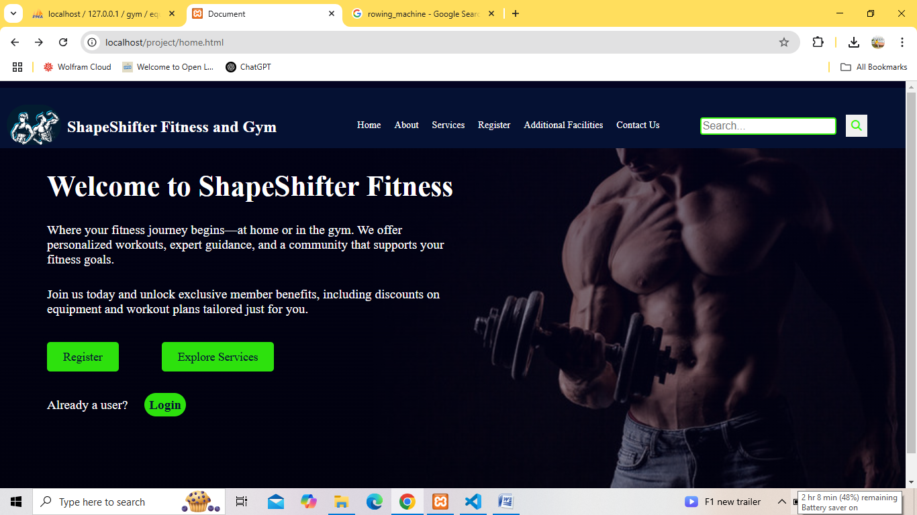

2.About Section
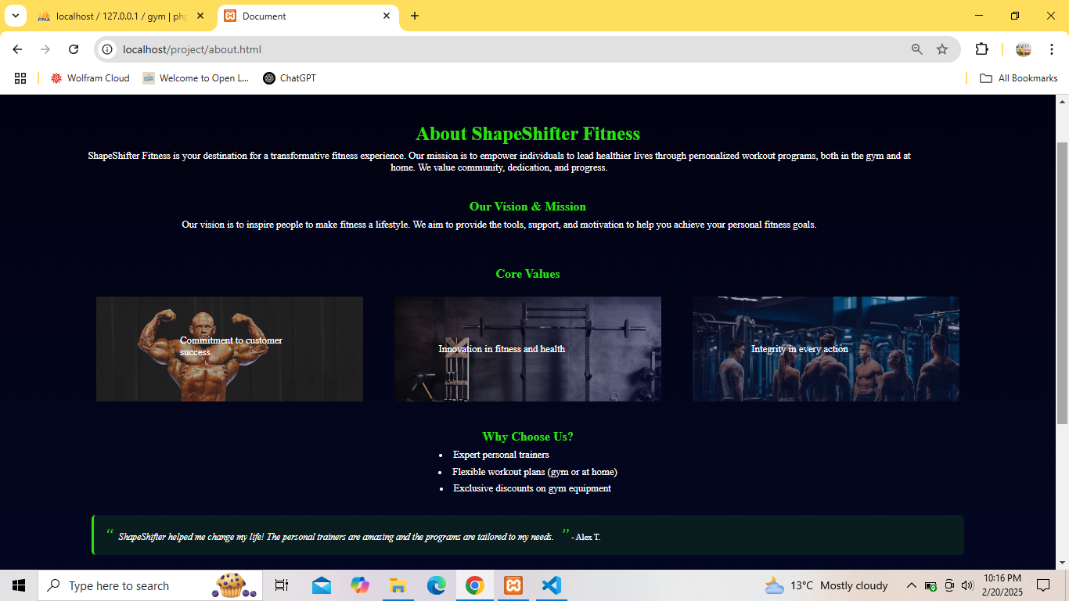

3.Services Section
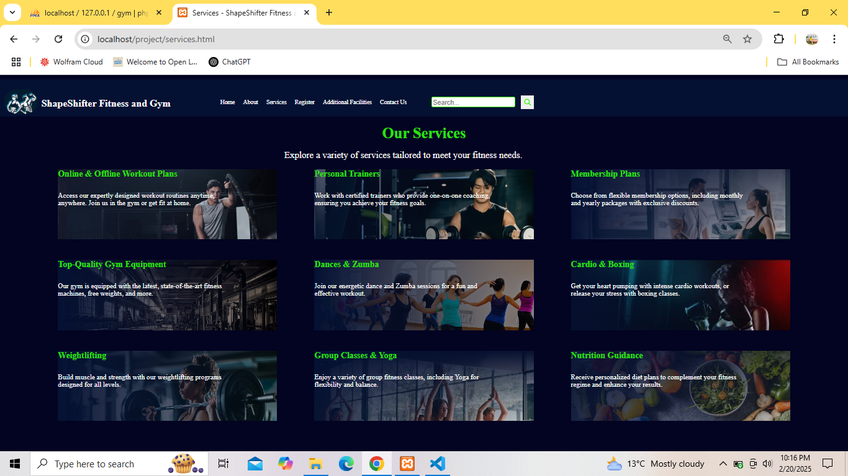

4.Registration Form
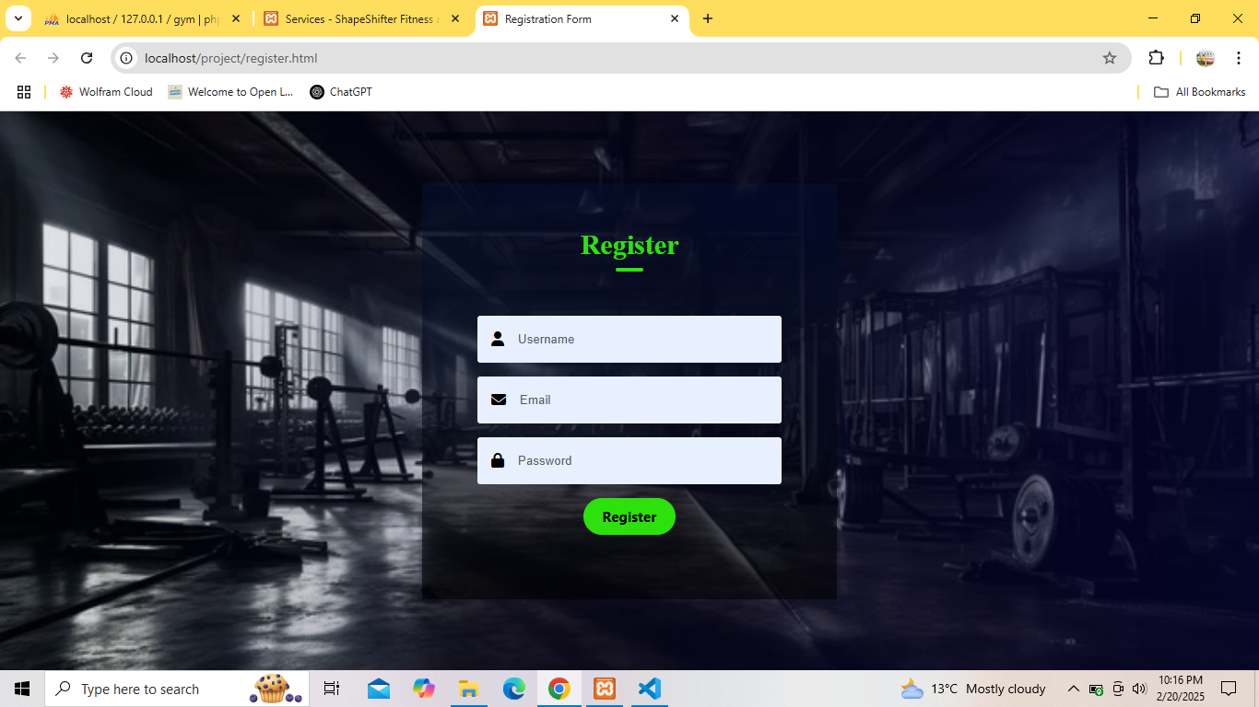

5.Additional Facilities Section
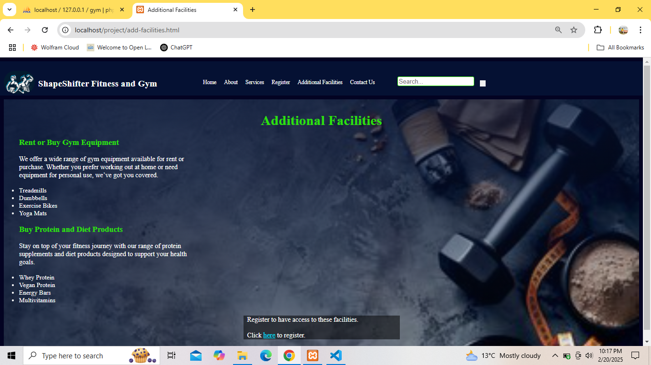

6.Contact Section
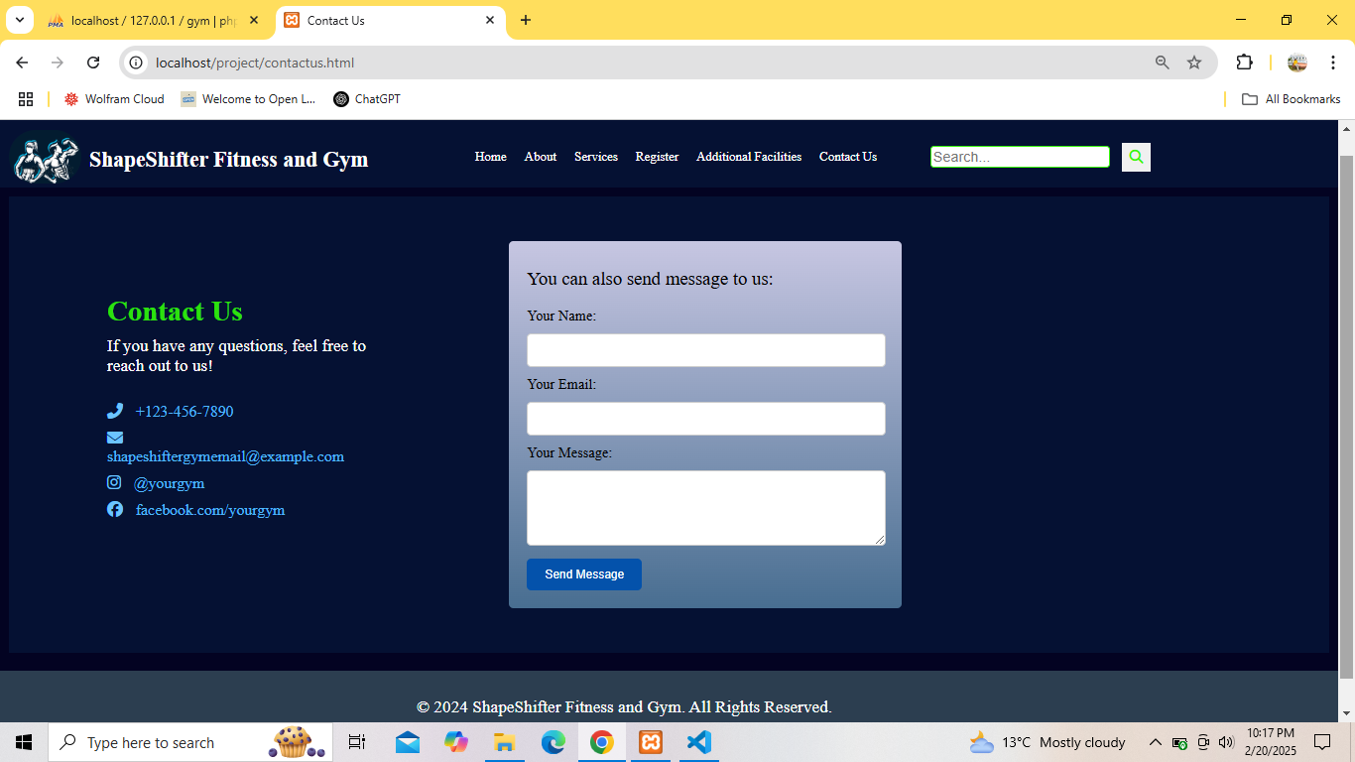

7.Login Form
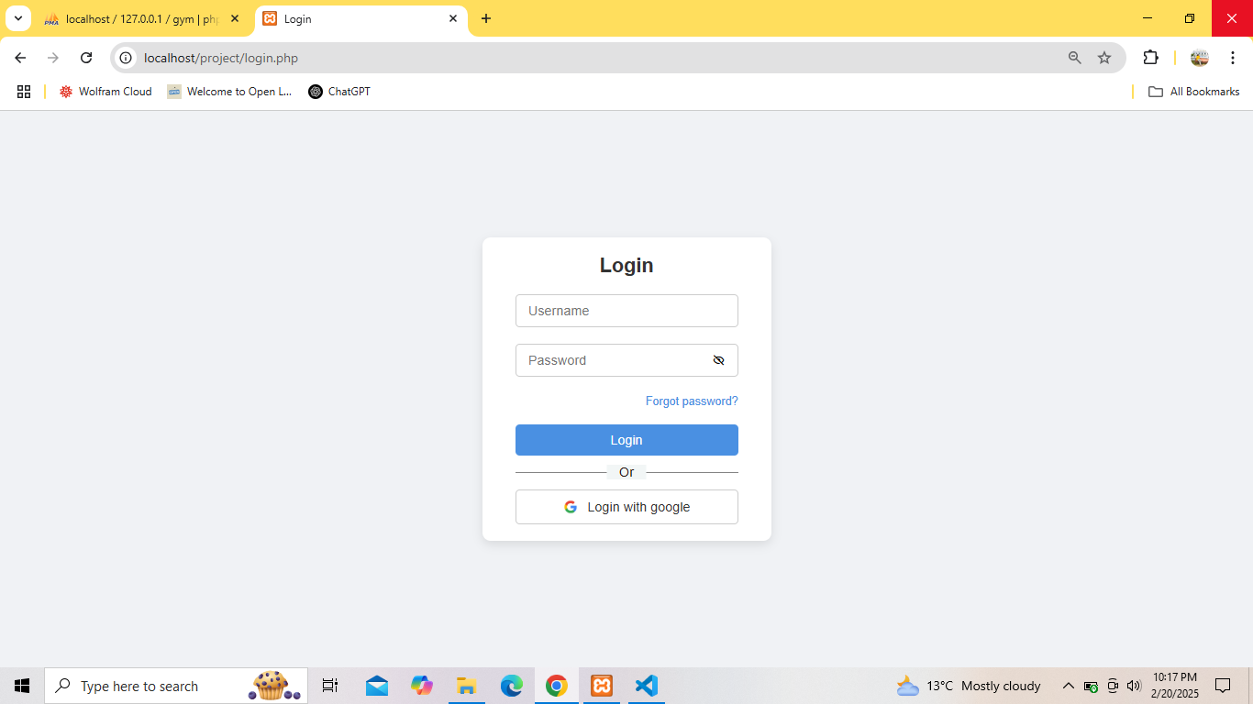

8.Admin Panel
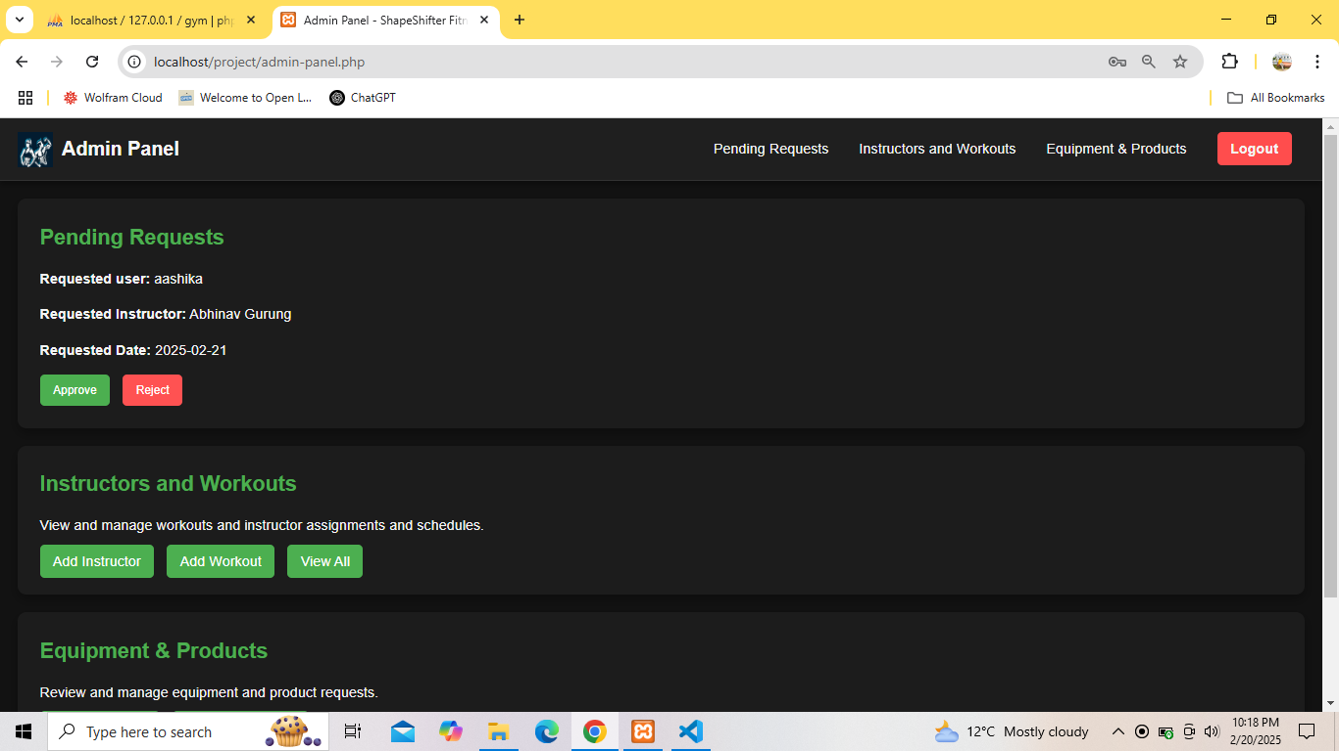

9.Equipment and Product Section
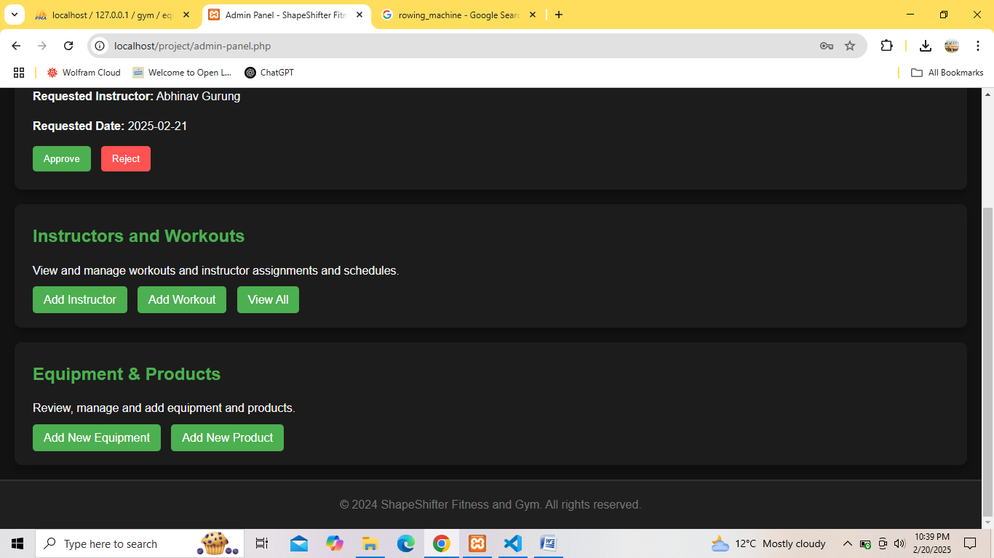

10.Dashboard
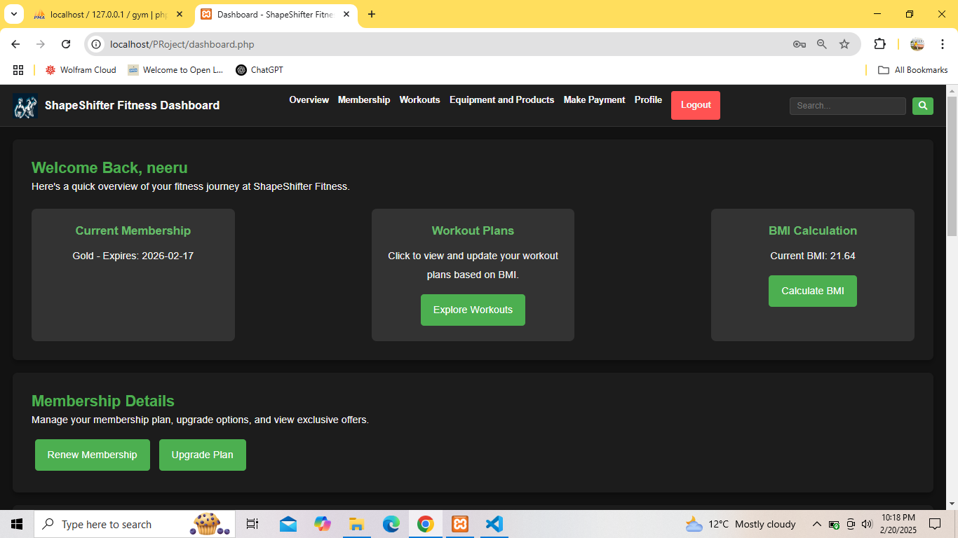
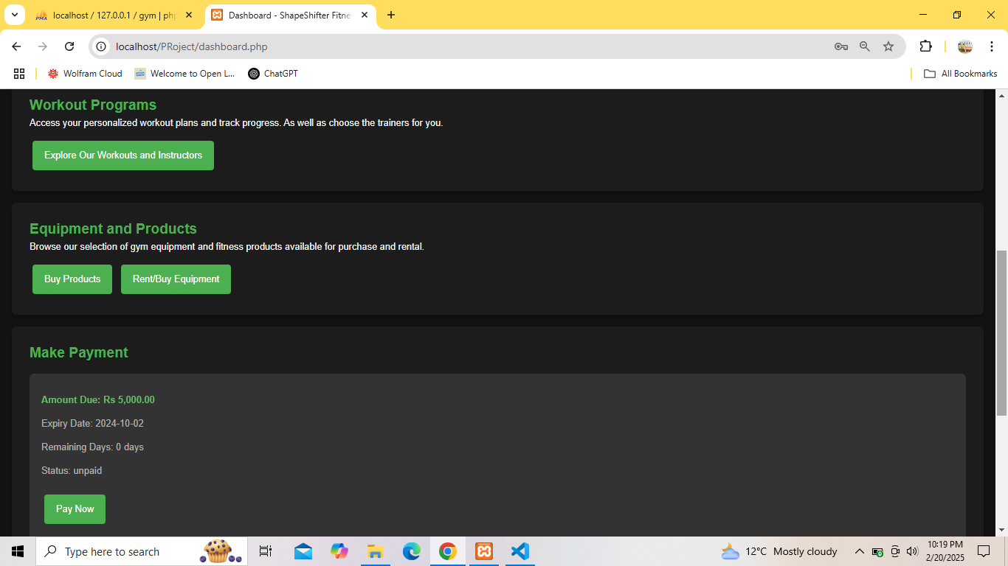

11.Profile Section
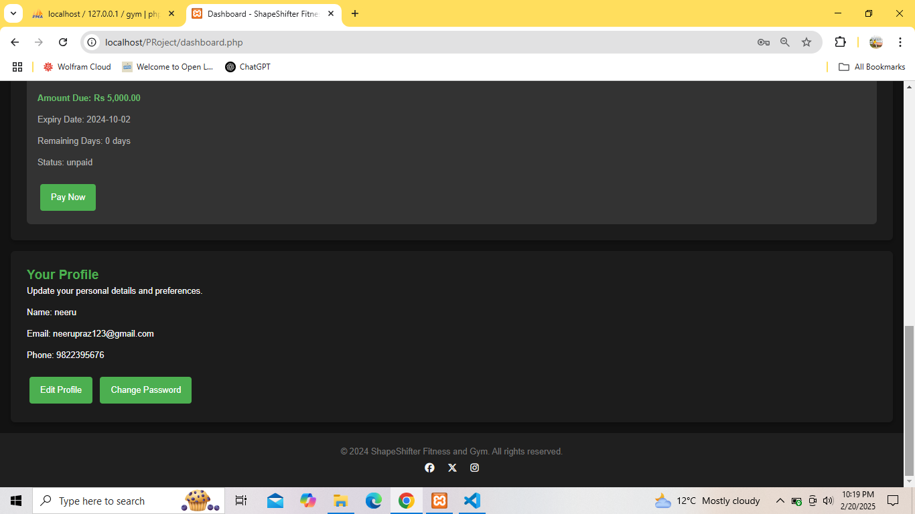

12.Products and Equipment

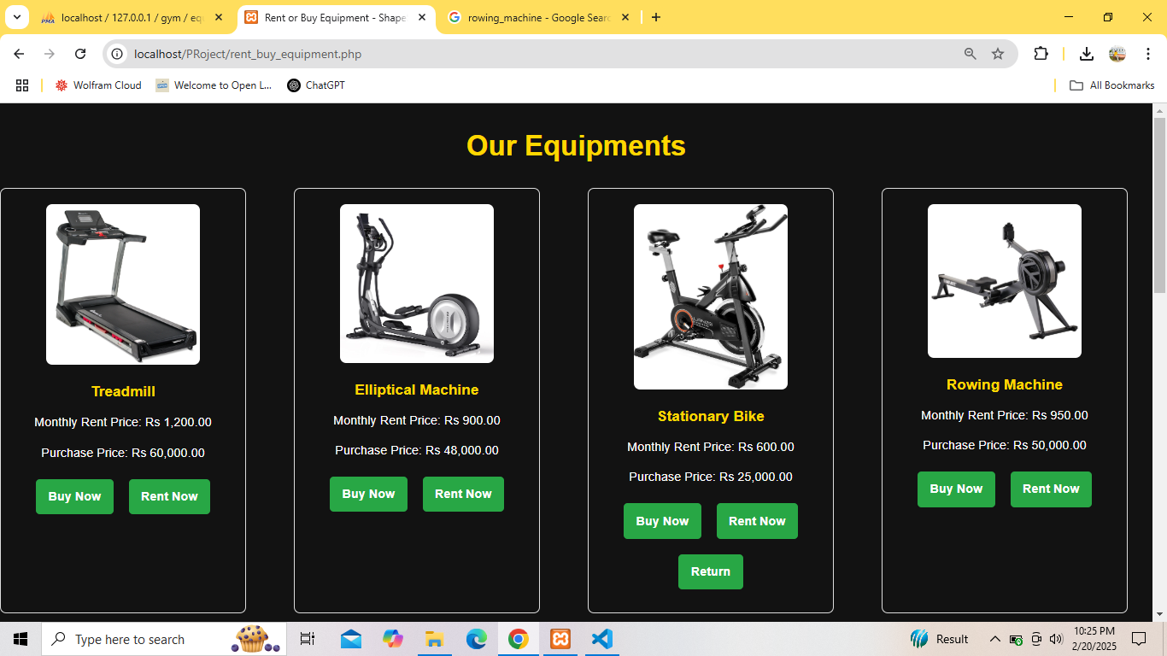

References

[1] | "Mindbody," 20 May 2000. [Online]. Available: https://www.mindbodyonline.com.
[2] | S. O. Roberts, in The Business of Personal Training, Human Kinetics, 1995.
[3] | C. Cooper, in Two-Brain Business: Grow Your Gym, CreateSpace Independent Publishing Platform, 2016.
[4] | J. Heffernan, in A Complete Guide to Gym Management.
[5] | N. E. L. Maher, in Fitness Management: A Comprehensive Approach, 2007.
[6] | M. A. Taylor, "International Journal of Sports Science and Fitness," 2017.
[7] | "International Fitness Association Report," International Sportsclub & Fitness Association, 2015.
[8] | "Fitness Industry Quarterly," ResearchGate, 2020.
[9] | "Fitness Business Podcast," Fitness Association, 2020.
[10] | "Gymcatch," 06 March 2017. [Online]. Available: https://gymcatch.com/.

